IT457 Cloud Computing

Lab 4: Cosmos DB and ASP.NET.

Akshar Panchani (ID - 202101522 )

**Question – 1**

Inserting Item and inserted list: -

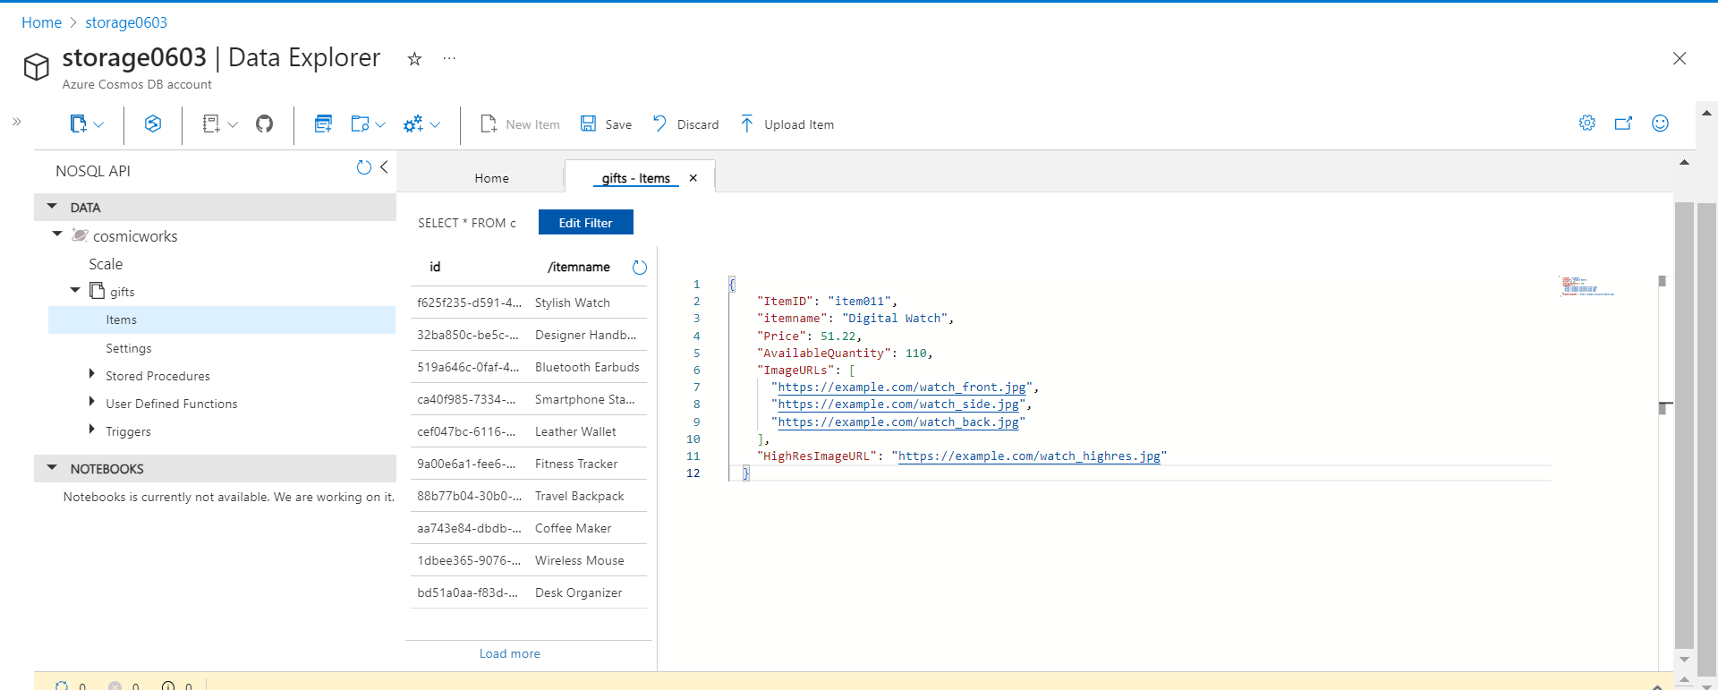

Deleting item and deleted items: -

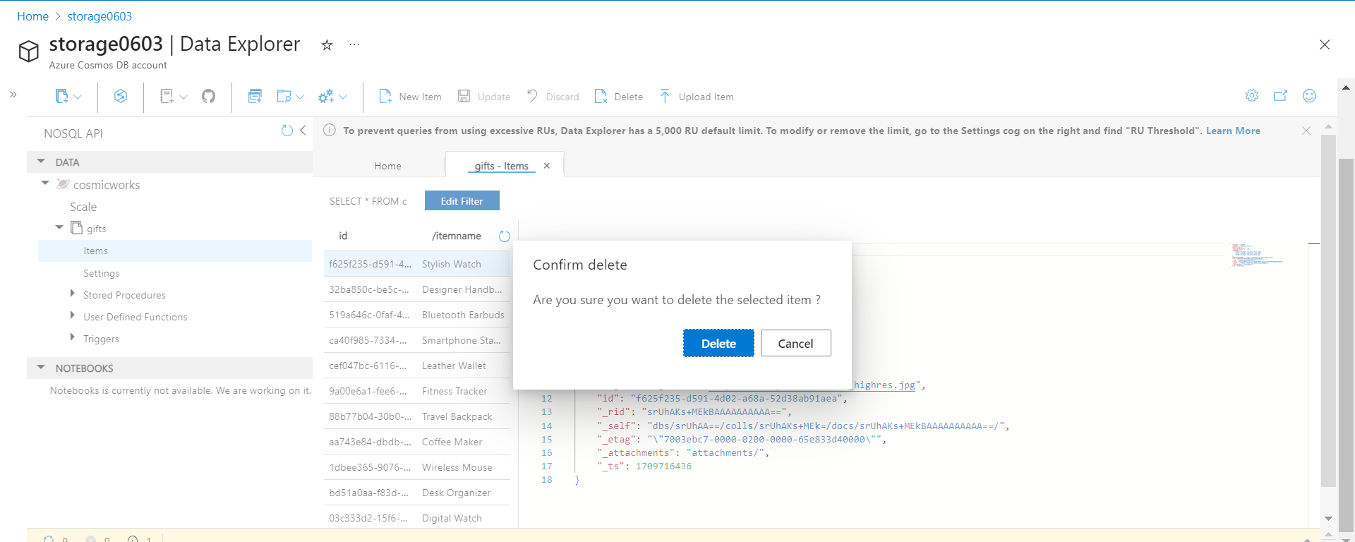

Updating item: -

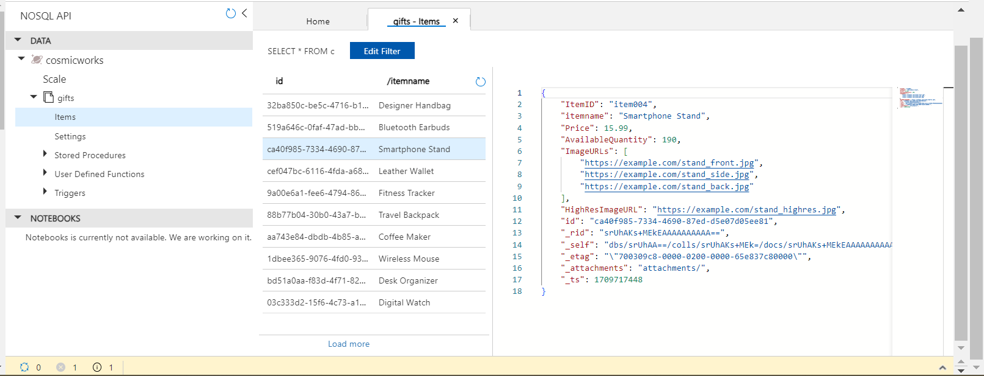

Query Execution: -

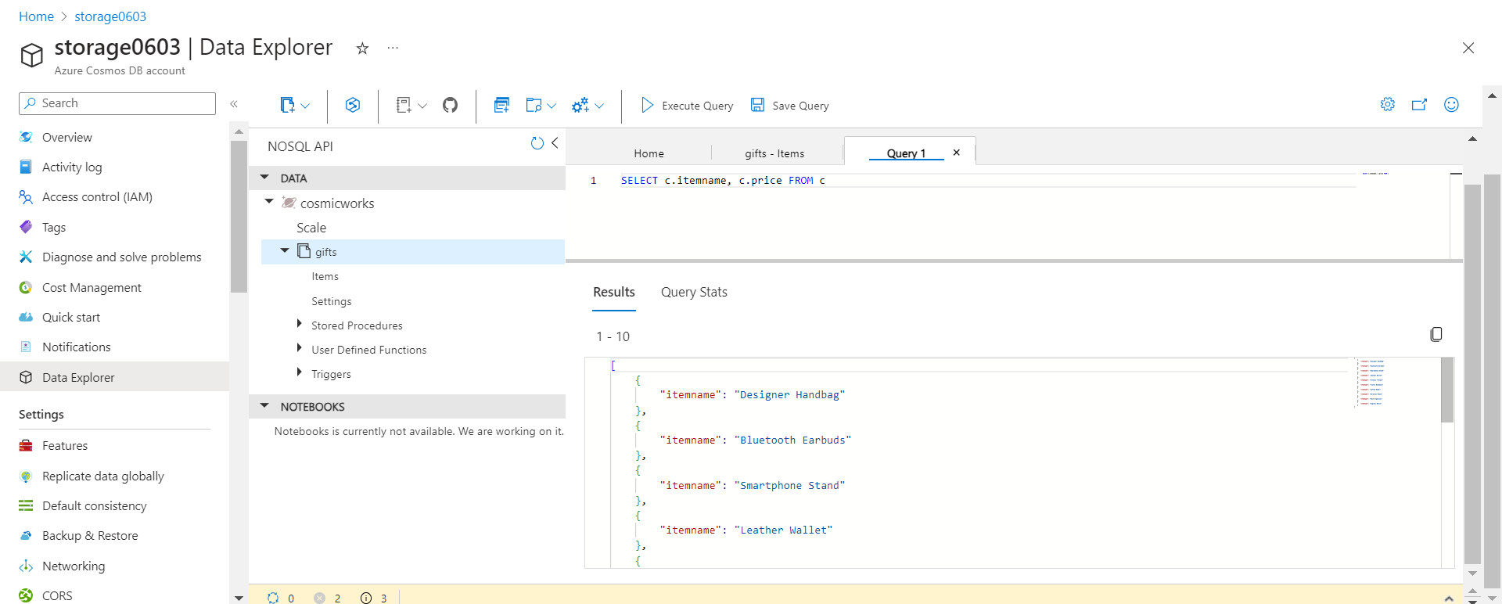

Items uploaded in modules container:

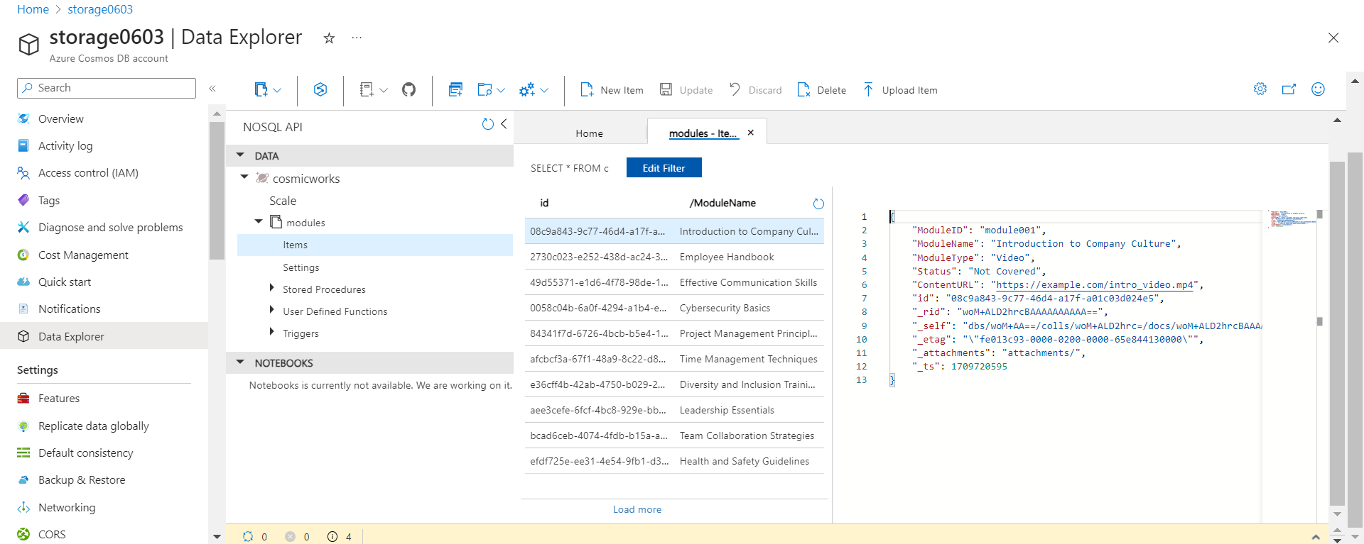

Inserting Item and inserted item: -

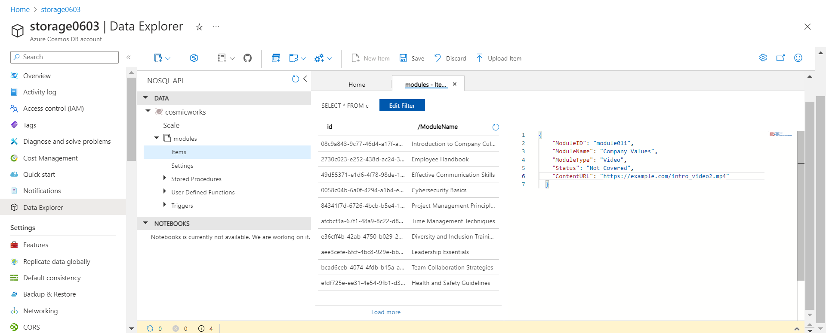

Item deleted and Updating item: -

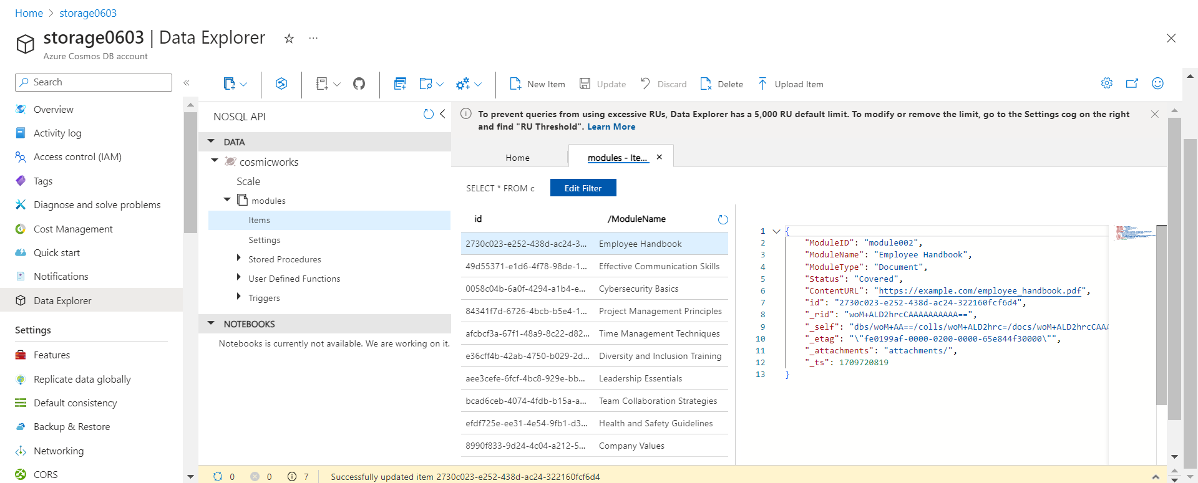

Query Execution: -

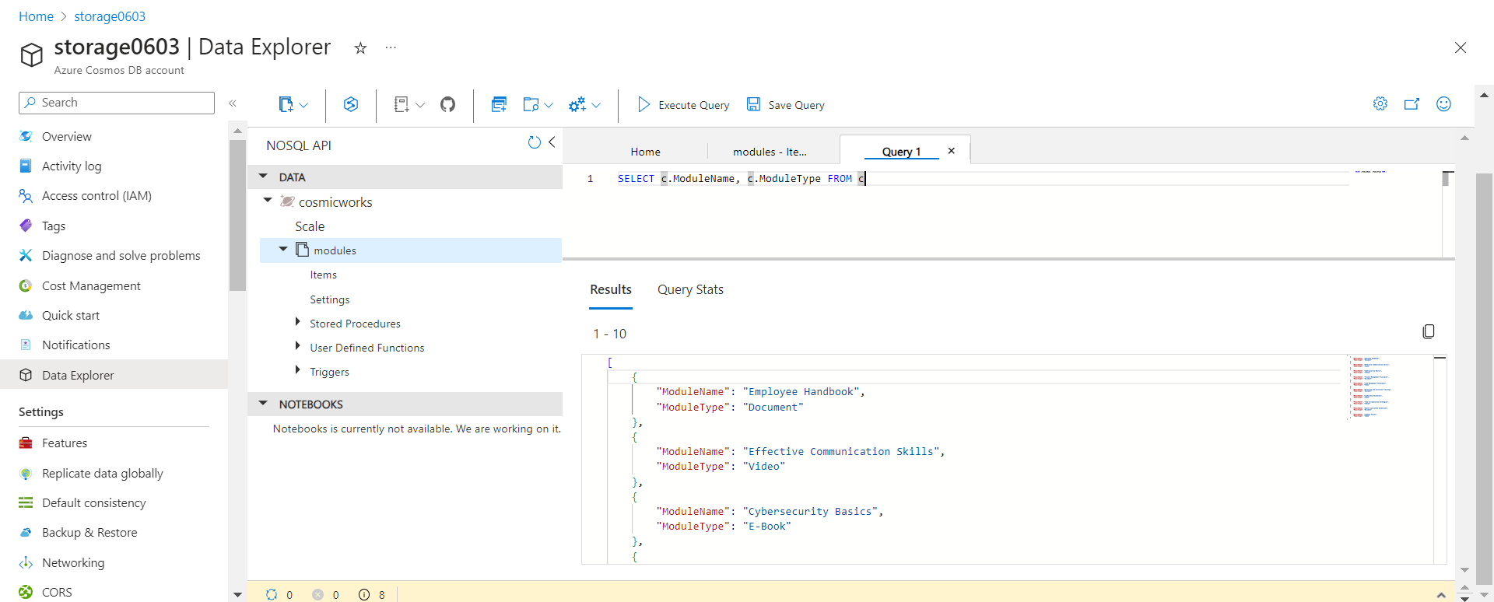

**Question - 2**

Develop an ASP.NET web application with Azure Cosmos DB for NoSQL

Data Population: -

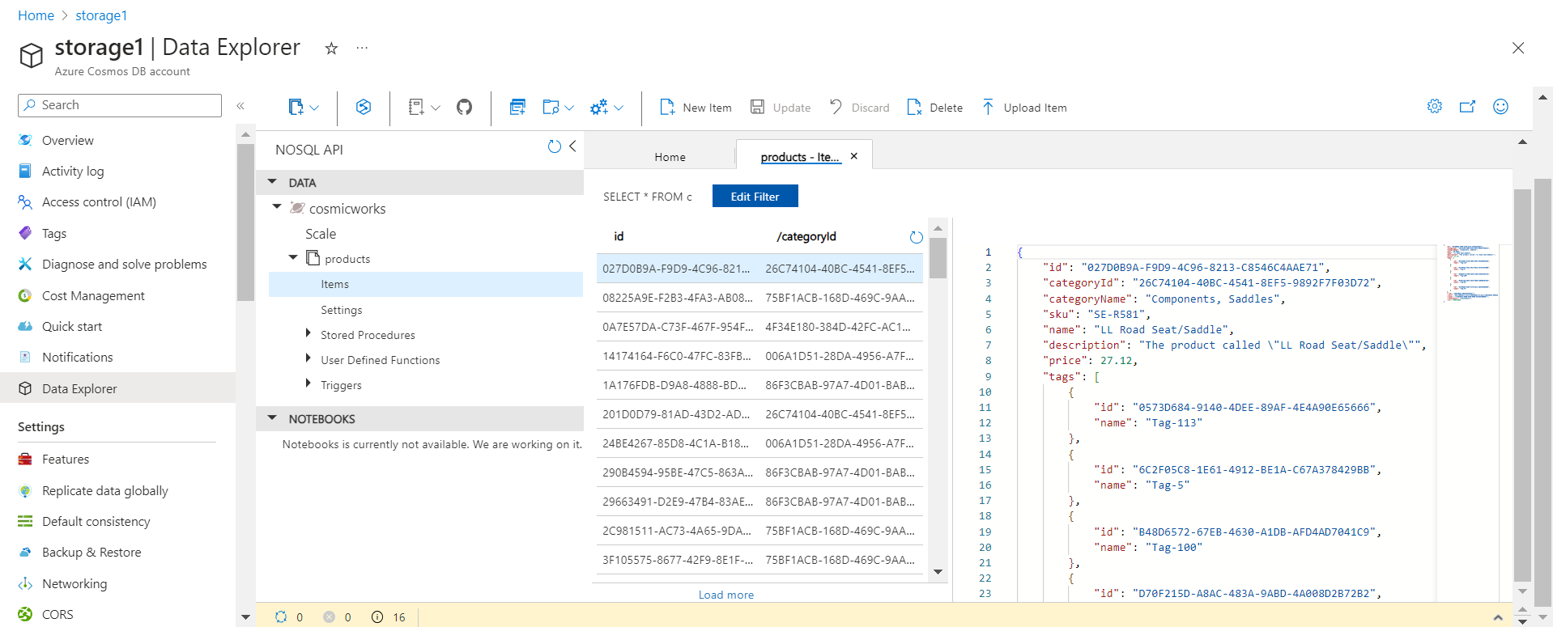

Query Executions: -

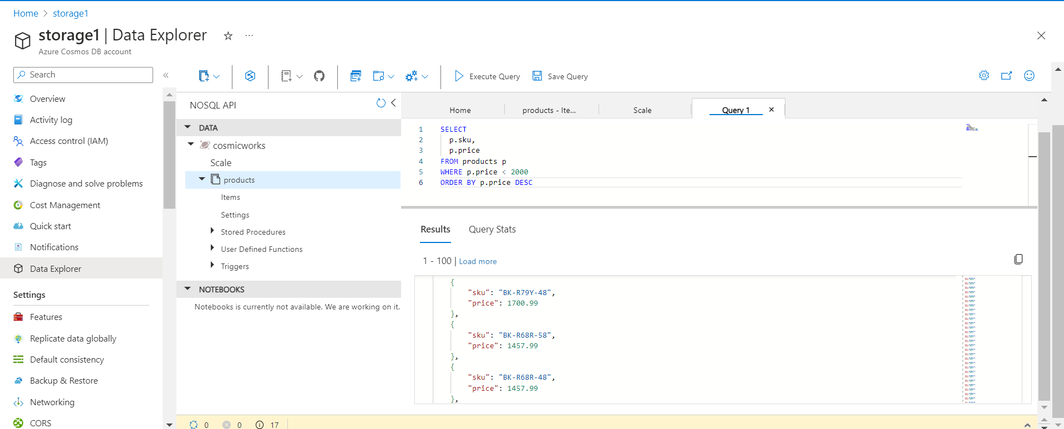

Building and running application:-

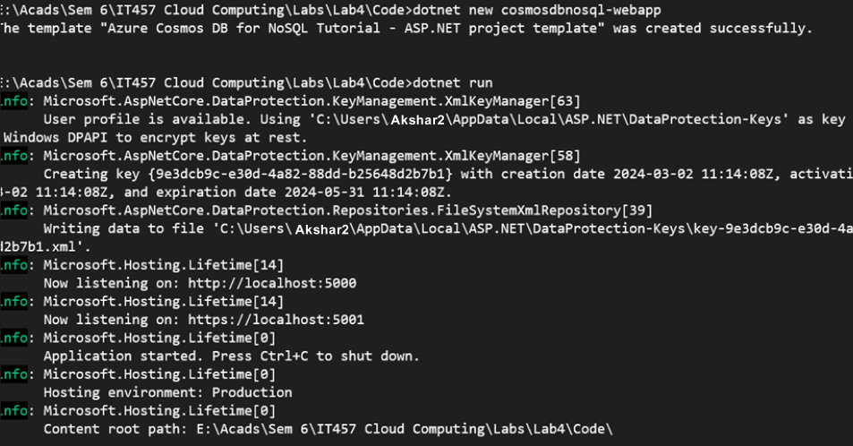

Adding code and running the application: -

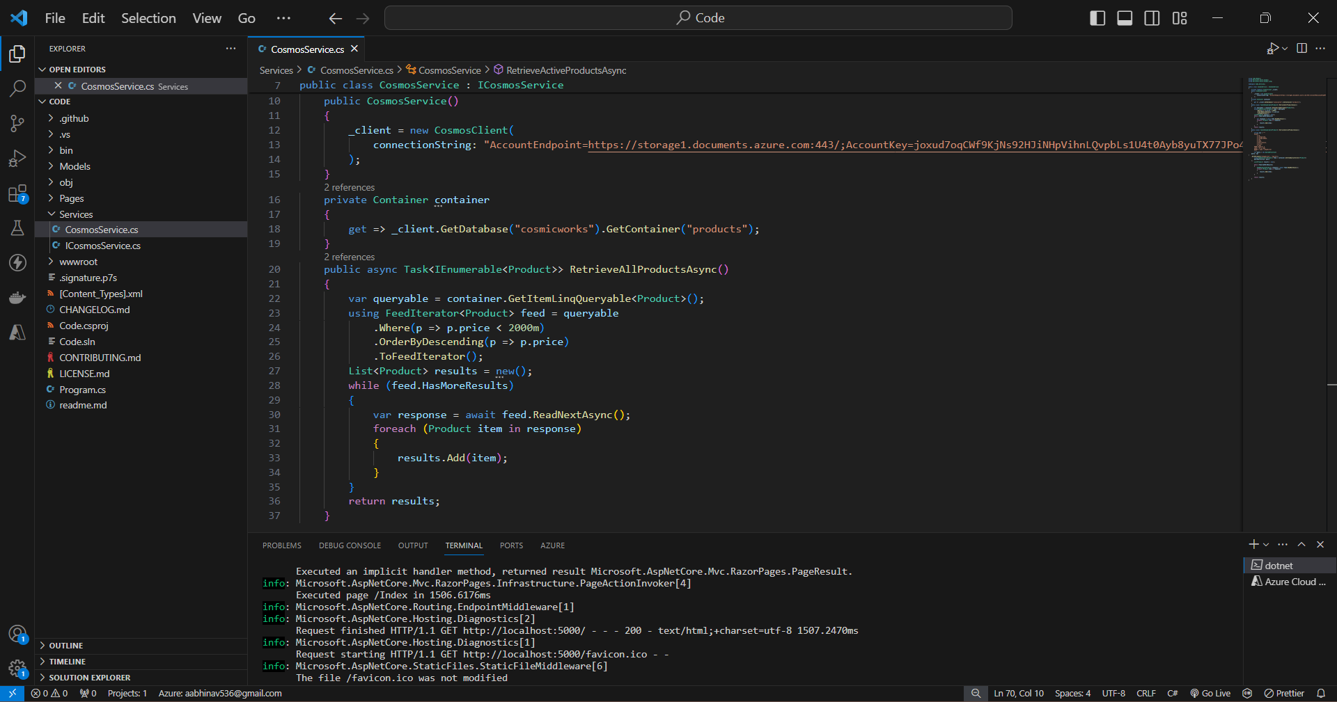

Updated list of products from the Azure Cosmos DB database with prices descending

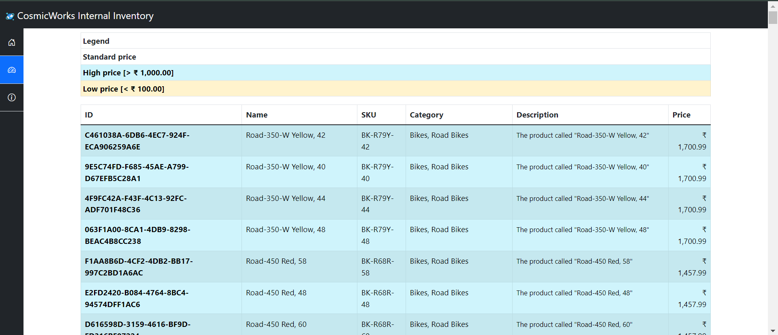

Azure Cosmos DB – end to end example:

Storage account, database, container, and items: -

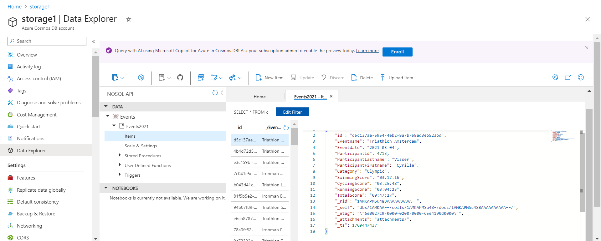

Executing query: -

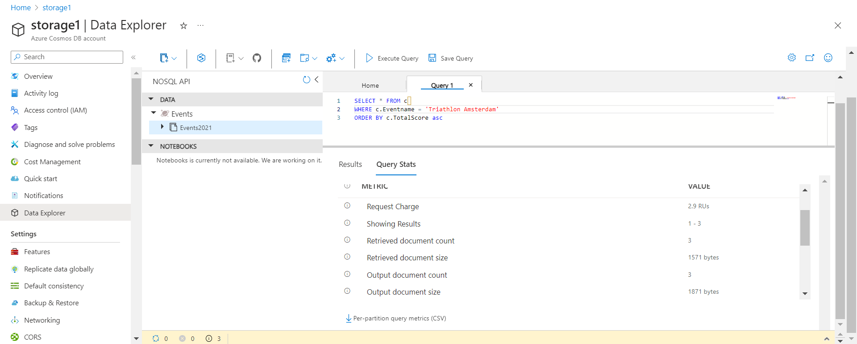

New indexing policy: -

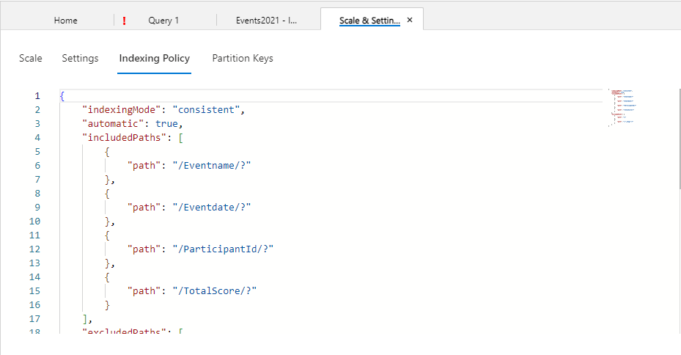

Optimized querying: -

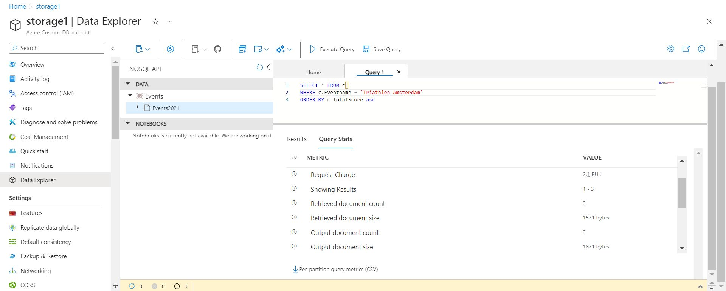

Azure Cosmos DB for Table for .NET

Creating Cosmos DB account using Azure PowerShell:

l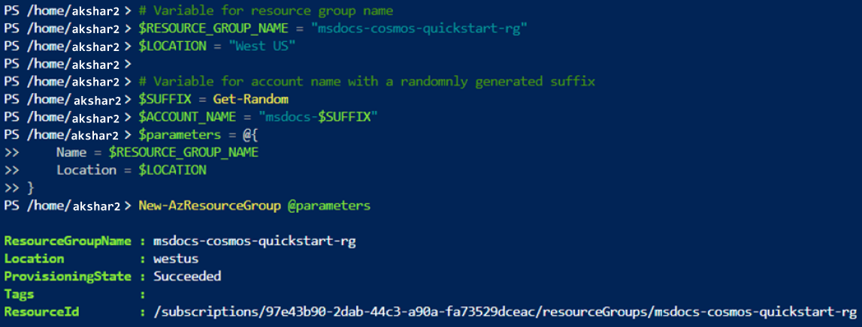

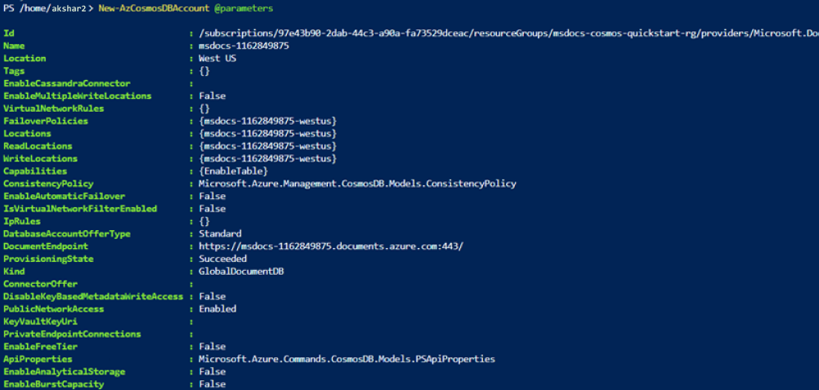

Getting document endpoints: -

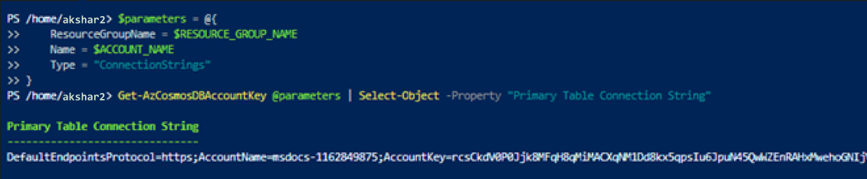

Code: -

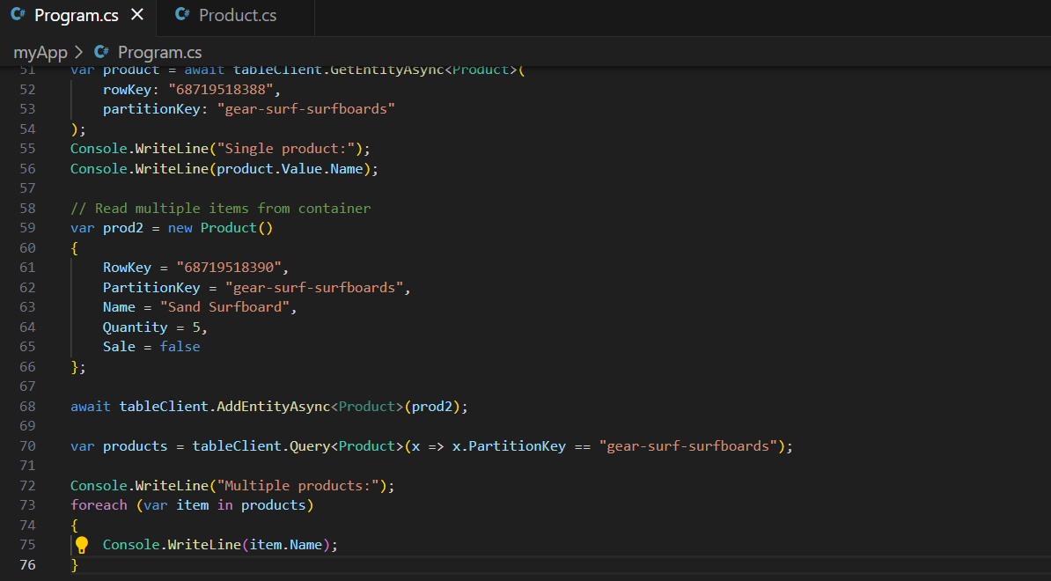

Output: -

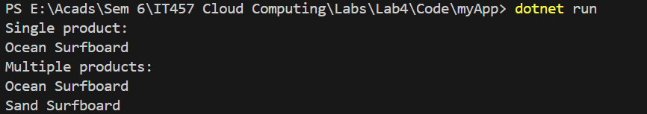

Output on Azure portal: -

